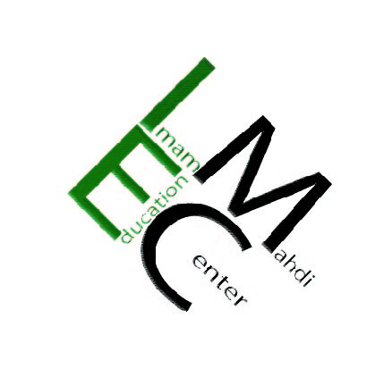
786-92-110
Imam Mahdi Education Center

Dear Respected Brothers and Sisters, December 14, 2014
Assalamu Alaikum Wa Rahmatullah Wa Barakatuh
As you already know, IMEC is trying hard to pay off its loan of $921,000.00 (nine hundred twenty-one thousand dollars) with your sincere Dua and generous support. We have come up with a plan to pay off this amount in an orderly way. If every group donates an amount listed below, Inshallah, we will be able to pay it off by the end of 2014. You can also go to our website and donate via PayPal.
Group 1: 14 people donate $14,000.00= $196,000.00
Group 2: 12 people donate $10,000.00= $120,000.00
Group 3: 10 people donate $5,000.00= $50,000.00
Group 4: 30 people donate $3,000.00= $90,000.00
Group 5: 30 people donate $2,000.00= $60,000.00
Group 6: 200 people donate $1,000.00= $200,000.00
Group 7: 200 people donate $500.00= $100,000.00
Group 8: 300 people donate $250.00= $75,000.00
Group 9: 300 people donate $100.00= $30,000.00
Total: 1,096 people Total: $921,000.00

Please send us your email address, home address, & phone number so that we may contact you for live Dua and Ziyarat from the holy cities of Karbala, Madina, including other holy cities and for Tabaruk gifts. Thank You, JazakumAllah Khayr. Ahsantum.

25450 Old Hundred Rd Dickerson MD 20842 (301)874-1631
www.ImamMahdiCenter.com, ImamMahdiCenter@Yahoo.com

