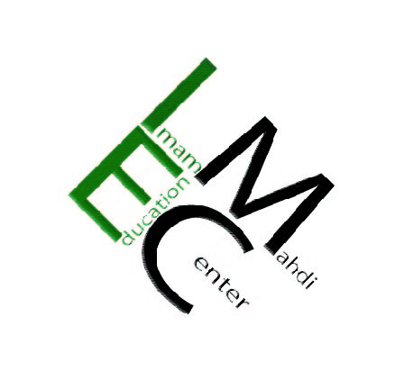
786-92-110
Imam Mahdi Education Center

“The mosques of Allah shall be visited and maintained by such as believe in Allah and the last day, establish regular prayers, and practice regular charity, and fear none except Allah. It is they who are expected to be on true guidance. “Holy Quran (9:18)
“When you are rich, seize the opportunity to give loan to a person who likes to pay you back when you direly need it” Ameer-ul-Mu’mineen, Imam Ali Ibne Abi Talib(as)
Dear respected Brothers and Sisters, December 14, 2014
Assalamu Alaikum Wa Rahmatullah Wa Barakatuh

IMEC thanks you very much and is in need of your continued assistance and support. The remaining balance of the loan for IMEC is $921,000 (nine hundred twenty-one thousand dollars); any amount contributed is greatly appreciated. Whether it is a qarz-e-hasana or a donation, it would help us get closer to our goal inshaAllah. In order to avoid paying interest, we are trying hard to pay off as much as we can of the remaining balance as soon as possible. Our goal is to pay it off soon, InshaAllah with your sincere dua and generous support.

IMEC is solely funded by grants, services, and individual donors. The center is a member of the North American Shia Ithna-Asheri Muslim Communities (NASIMCO) and has permission from several marajia (scholars) to receive khums and other huqooq.

Thank You for your constant support and may Allah (swt) fulfill all your needs and increase in your halal sustenance by the grace of the fourteen masoomeen(as).

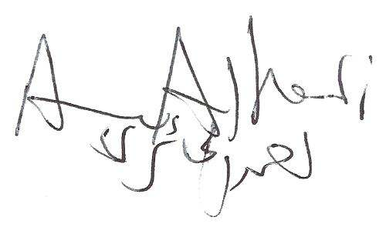
Wassalamu Alaikum

Shaikh Ahmad Alhaeri

25450 Old Hundred Rd Dickerson MD 20842 (301)874-1631
www.ImamMahdiCenter.com, ImamMahdiCenter@Yahoo.Com

